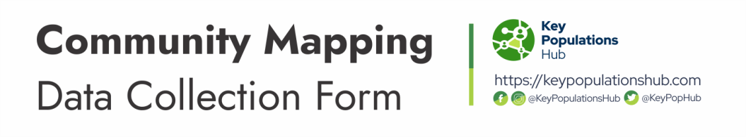
Kindly use the example format in the form below to add your entries.
SN | Name of Organization/Group | Target Community (Category) | About the organization/group | Contact information/Location
1. | Drug free & Preventive Healthcare Organization | People Who Use/Inject Drugs (PWUID) | DAPHO mobilizes a community of people who use, are affected, and/or are vulnerable to drug use to access non-discriminatory health and social services as a component of their Human rights. | Email: info@dapho.org  Website: dapho.org  Address/Location: Gombe
2.
3.
4.

To submit this form, go to https://keypopulationshub.com/community-mapping

